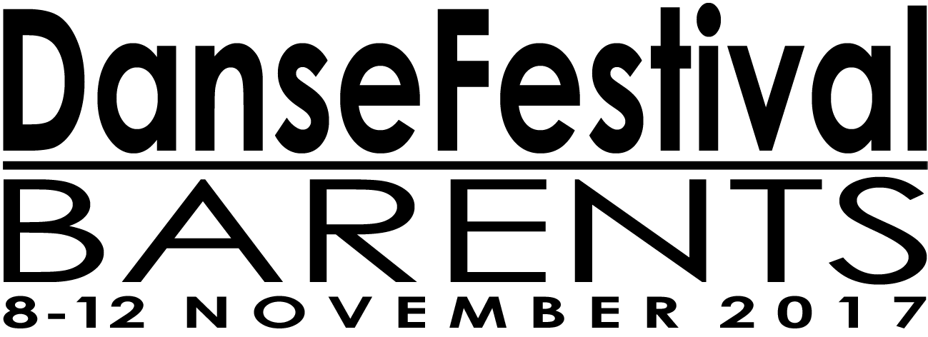

OPEN CALL APPLICATION FORM
Please write in Norwegian or English.
Please double-check your spelling as well as use of upper and lower case letters.
Form doesn’t fit your project proposal? Fill it out as best you can and send in appropriate attachments.

- COMPANY/ARTIST(S) NAME:

- TOWN/CITY AND COUNTRY OF ORIGIN:

- WEBSITE:

- GENRE:

- TITLE OF PIECE/PROJECT:

- DESCRIPTION:

- PREVIOUS PERFORMANCES/VENUES:

- UPCOMING PERFORMANCES/VENUES:

- DURATION/LENGHT:

- PERFORMERS:

- OTHER PEOPLE TRAVELLING AND THEIR ROLES:

- CREDITS:

- VIMEO/YOUTUBE LINK AND PASSWORD:
Full performances if possible. Or send DVD to DanseFestival Barents, Mylingen 6, 9601 Hammerfest, Norway. Please note that the DVD will not be returned.

- TECHNICAL DETAILS: (attach raider)

- PROPOSED PERFORMANCE FEE: (attach budget)

- OTHER INFORMATION:

ATTACH: BUDGET & RAIDER
MARK YOUR EMAIL WITH YOUR COMPANY/ARTIST NAME AND RETURN TO opencall@dansefestivalbarents.no

DEADLINE 10 JANUARY 2017.

